Module Name : Internet & Multimedia Applications Development
Module Code : ITP4523M

Student Name | Chen Hoi Yuk
Student Name | Chen Chun Tat

Each Project Group must use this Word document to clearly list the files you have created for Phase 1 (User Interface Design) of the Group Project.

Set the filename of your starting page to index.html or index.php
- UI Design for Index.html


- UI Design for Login
  - Login.html 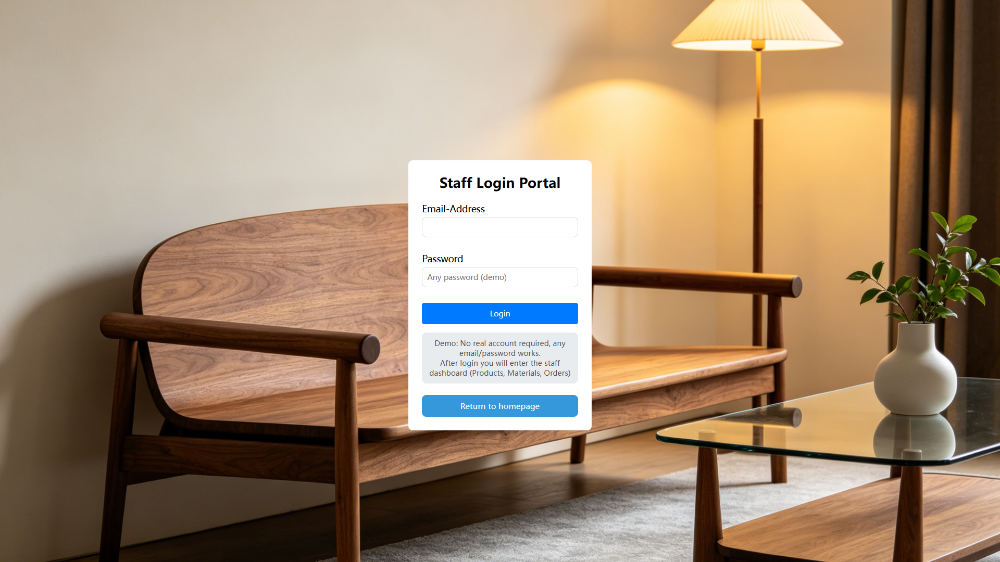
  - customerLogin.html
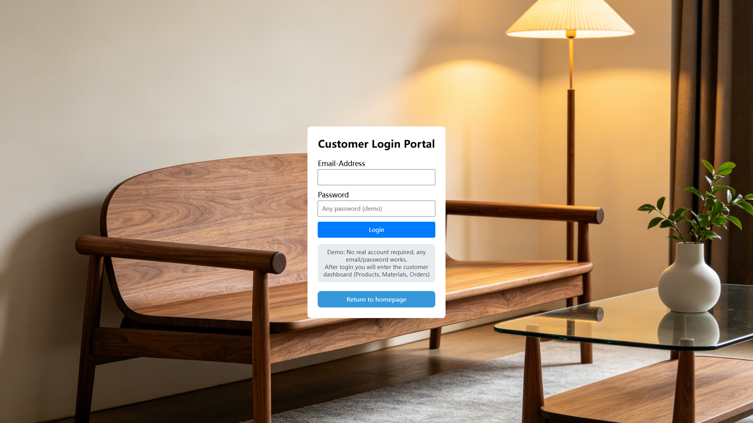

- UI Design for prodecuList.html
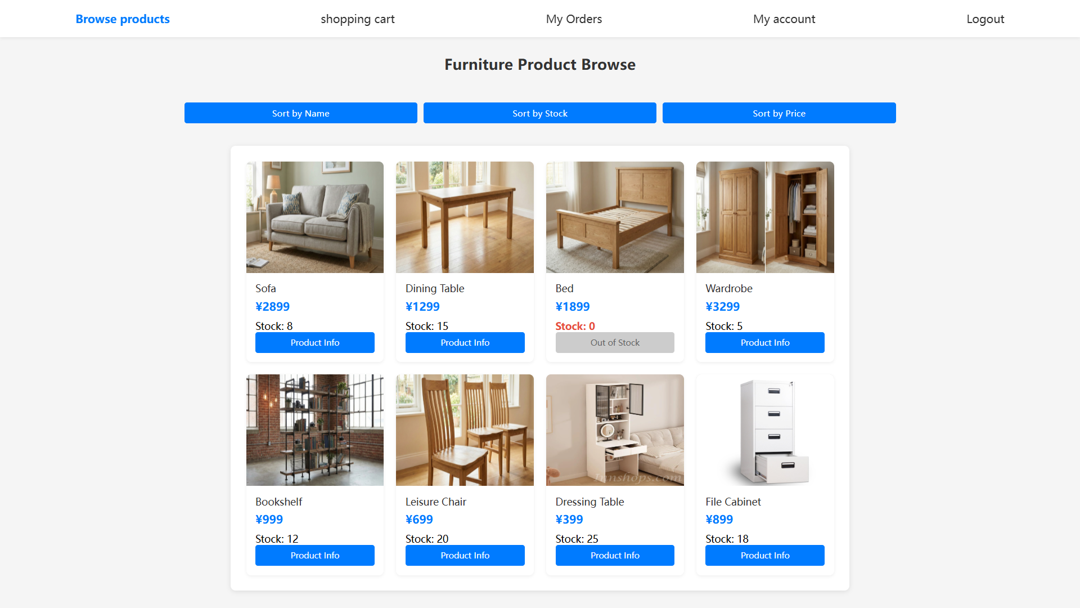
- UI Design for furnitureInfo.html
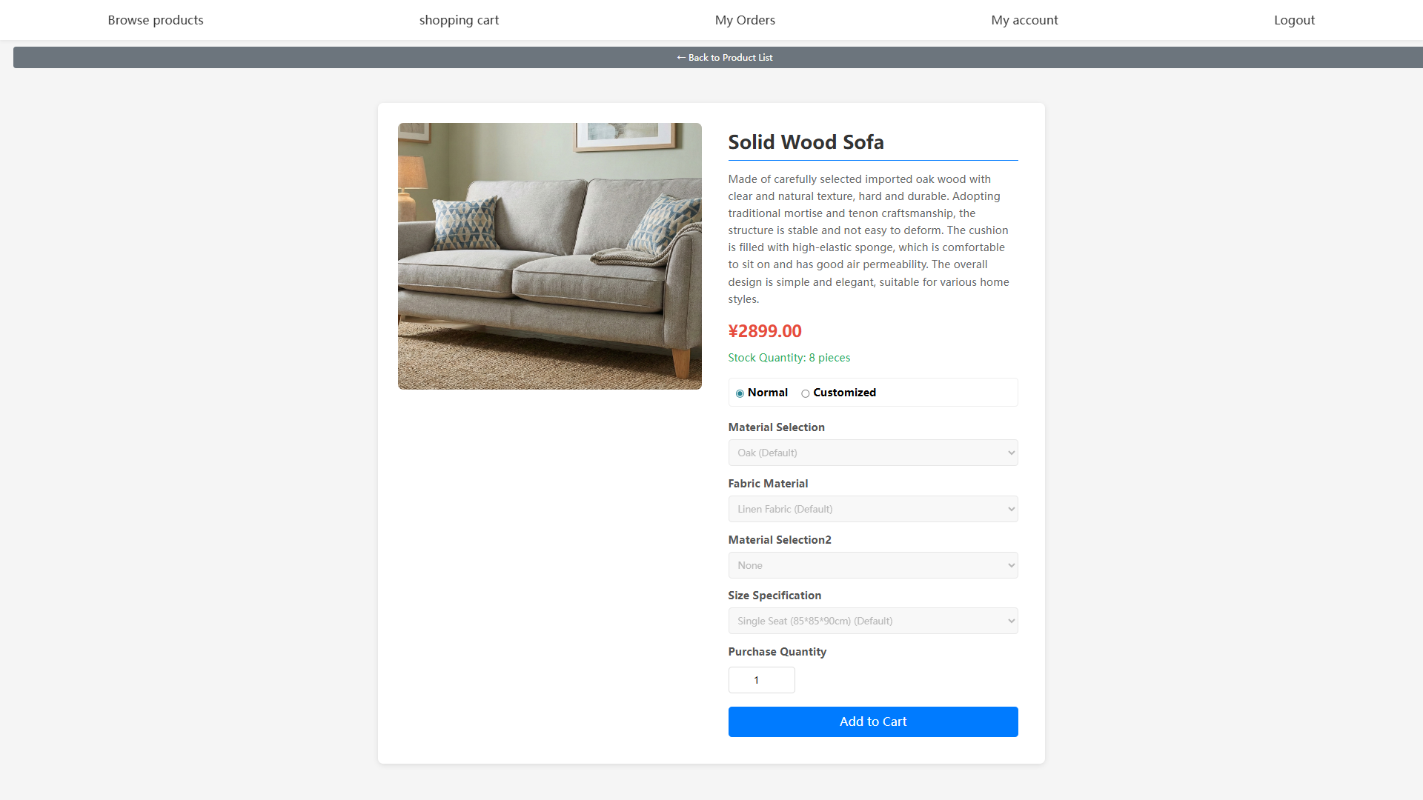

- UI Design for cart.html
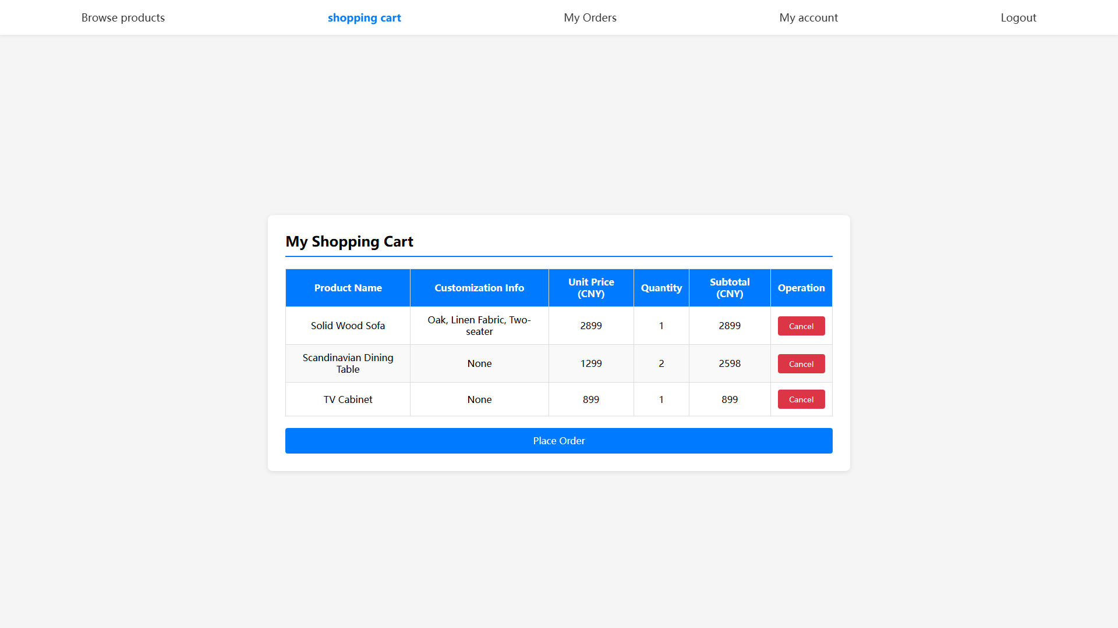

- UI Design for order.html
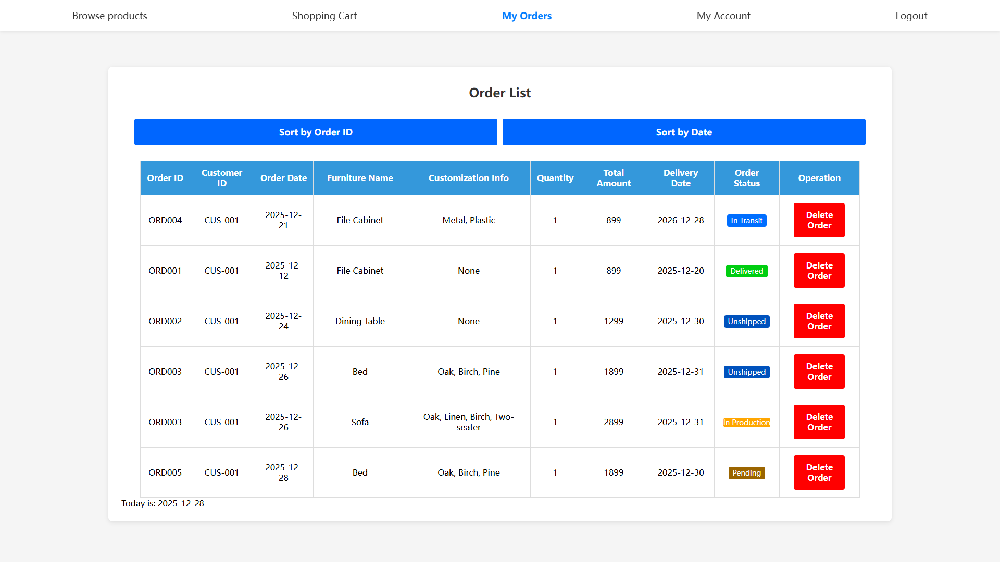

- UI Design for myAccount.html
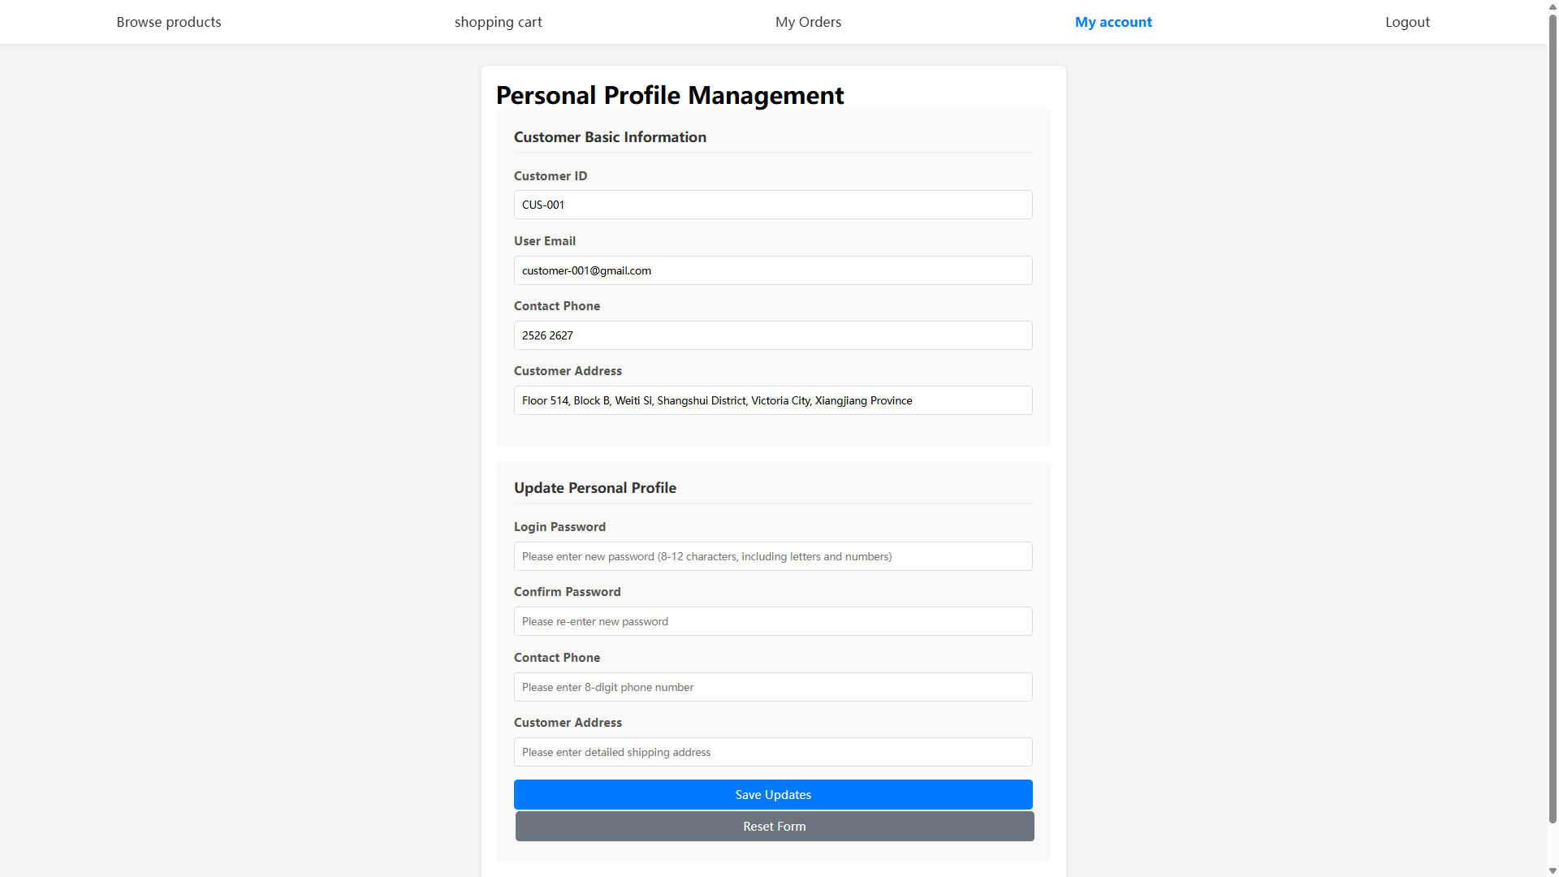

- UI Design for staff_dashboard.html
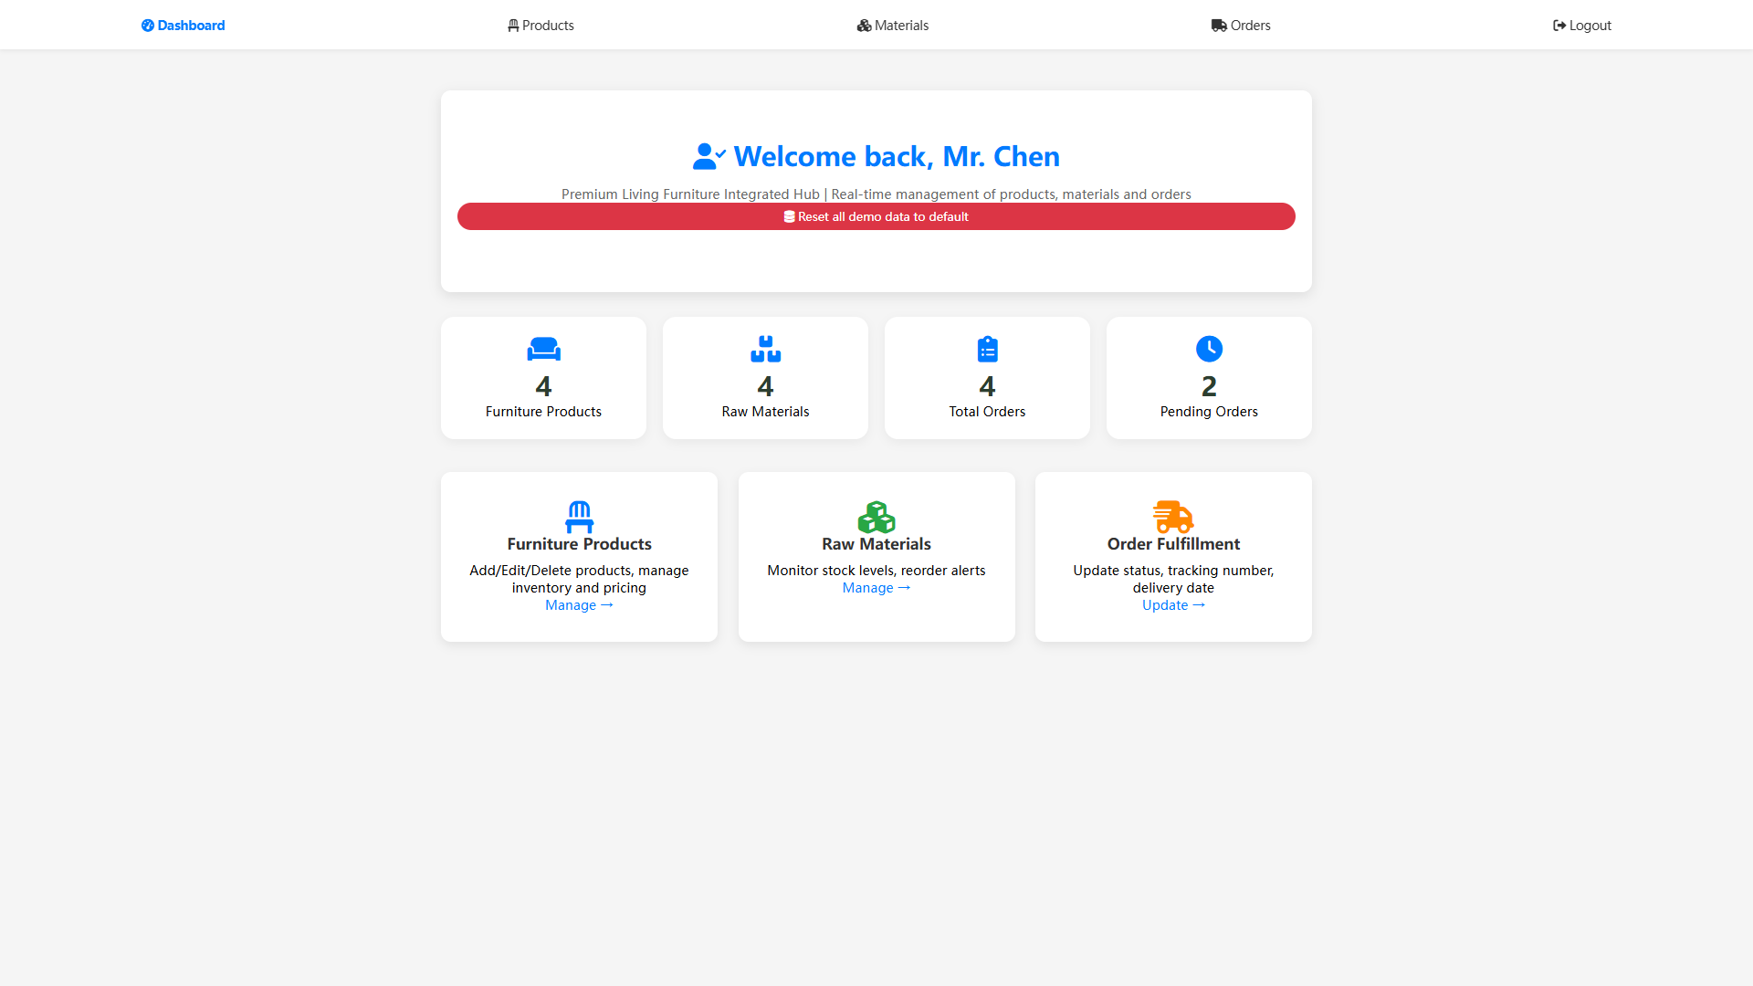

- UI Design for staff_products.html
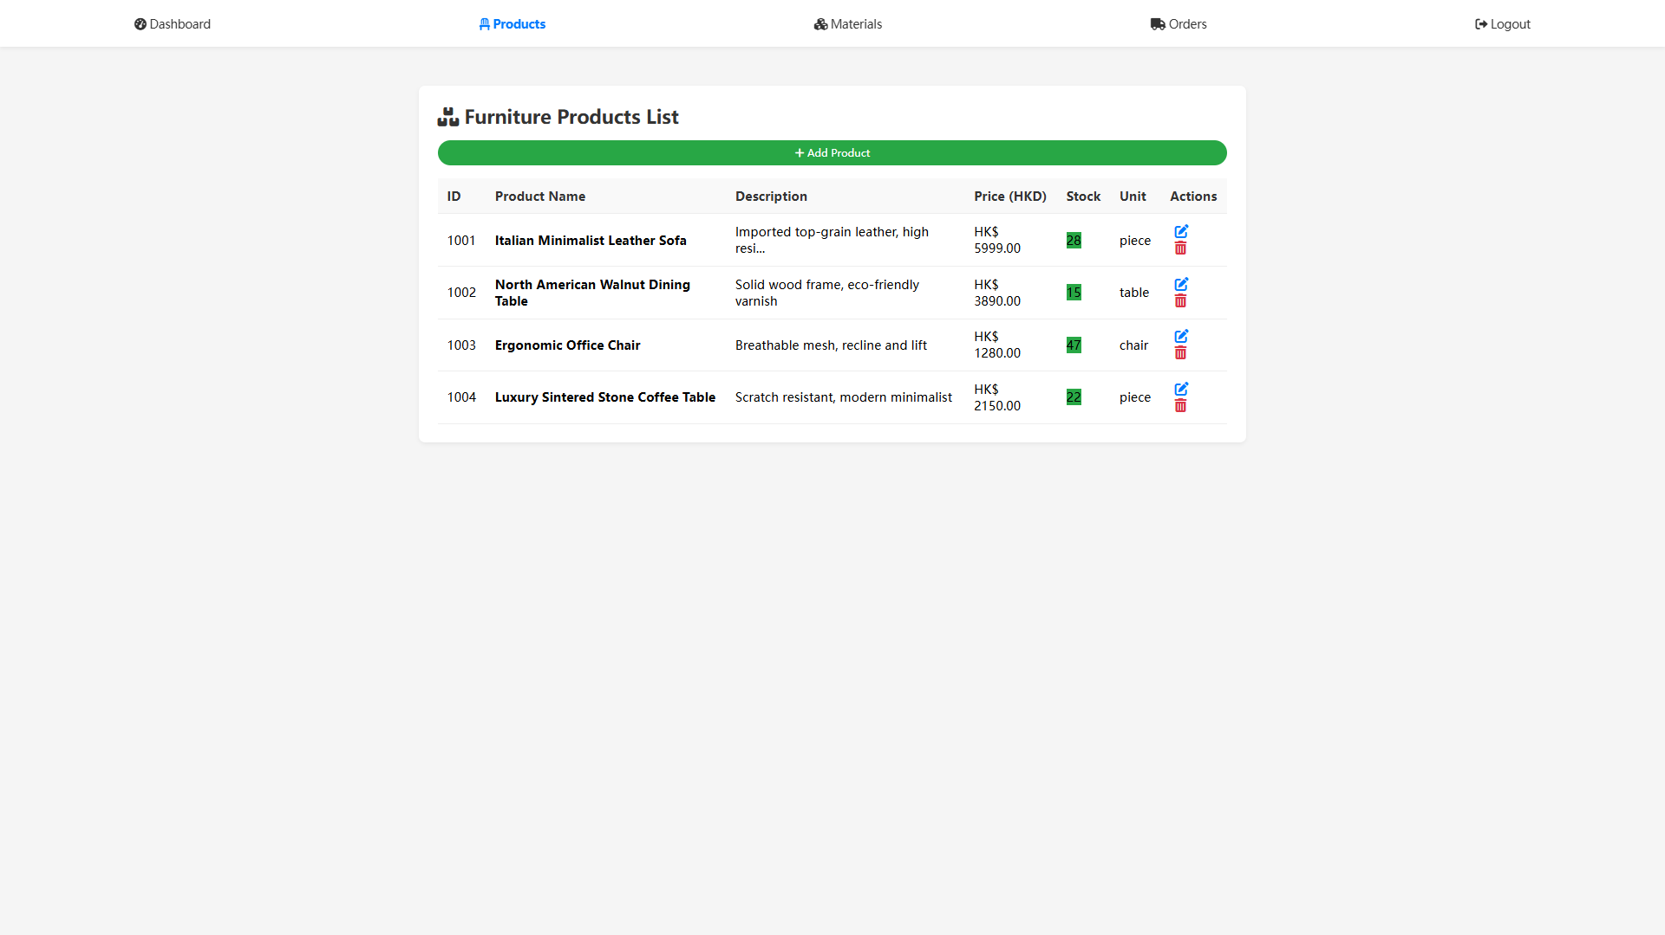
- UI Design for staff_materials.html
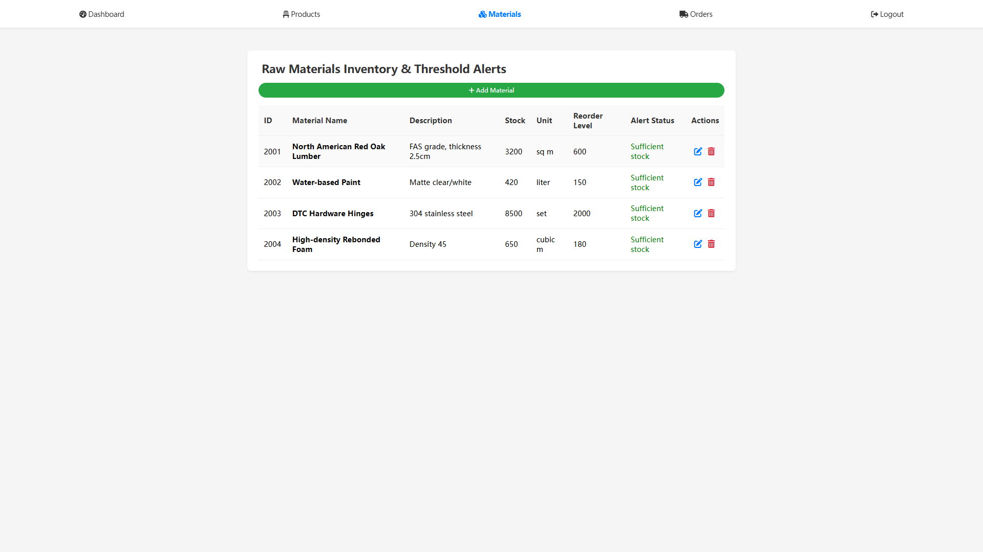

- UI Design for staff_orders.html
